

What will I need?
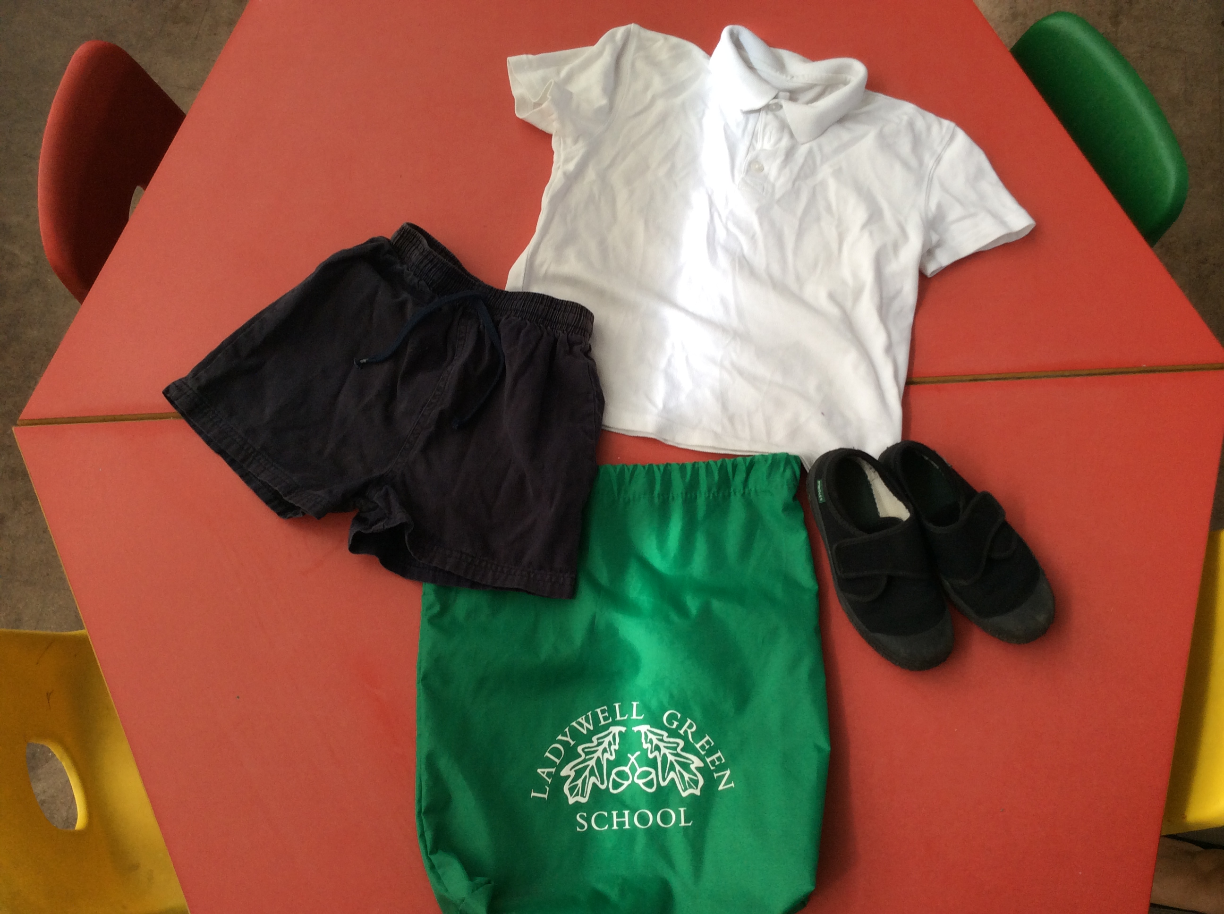
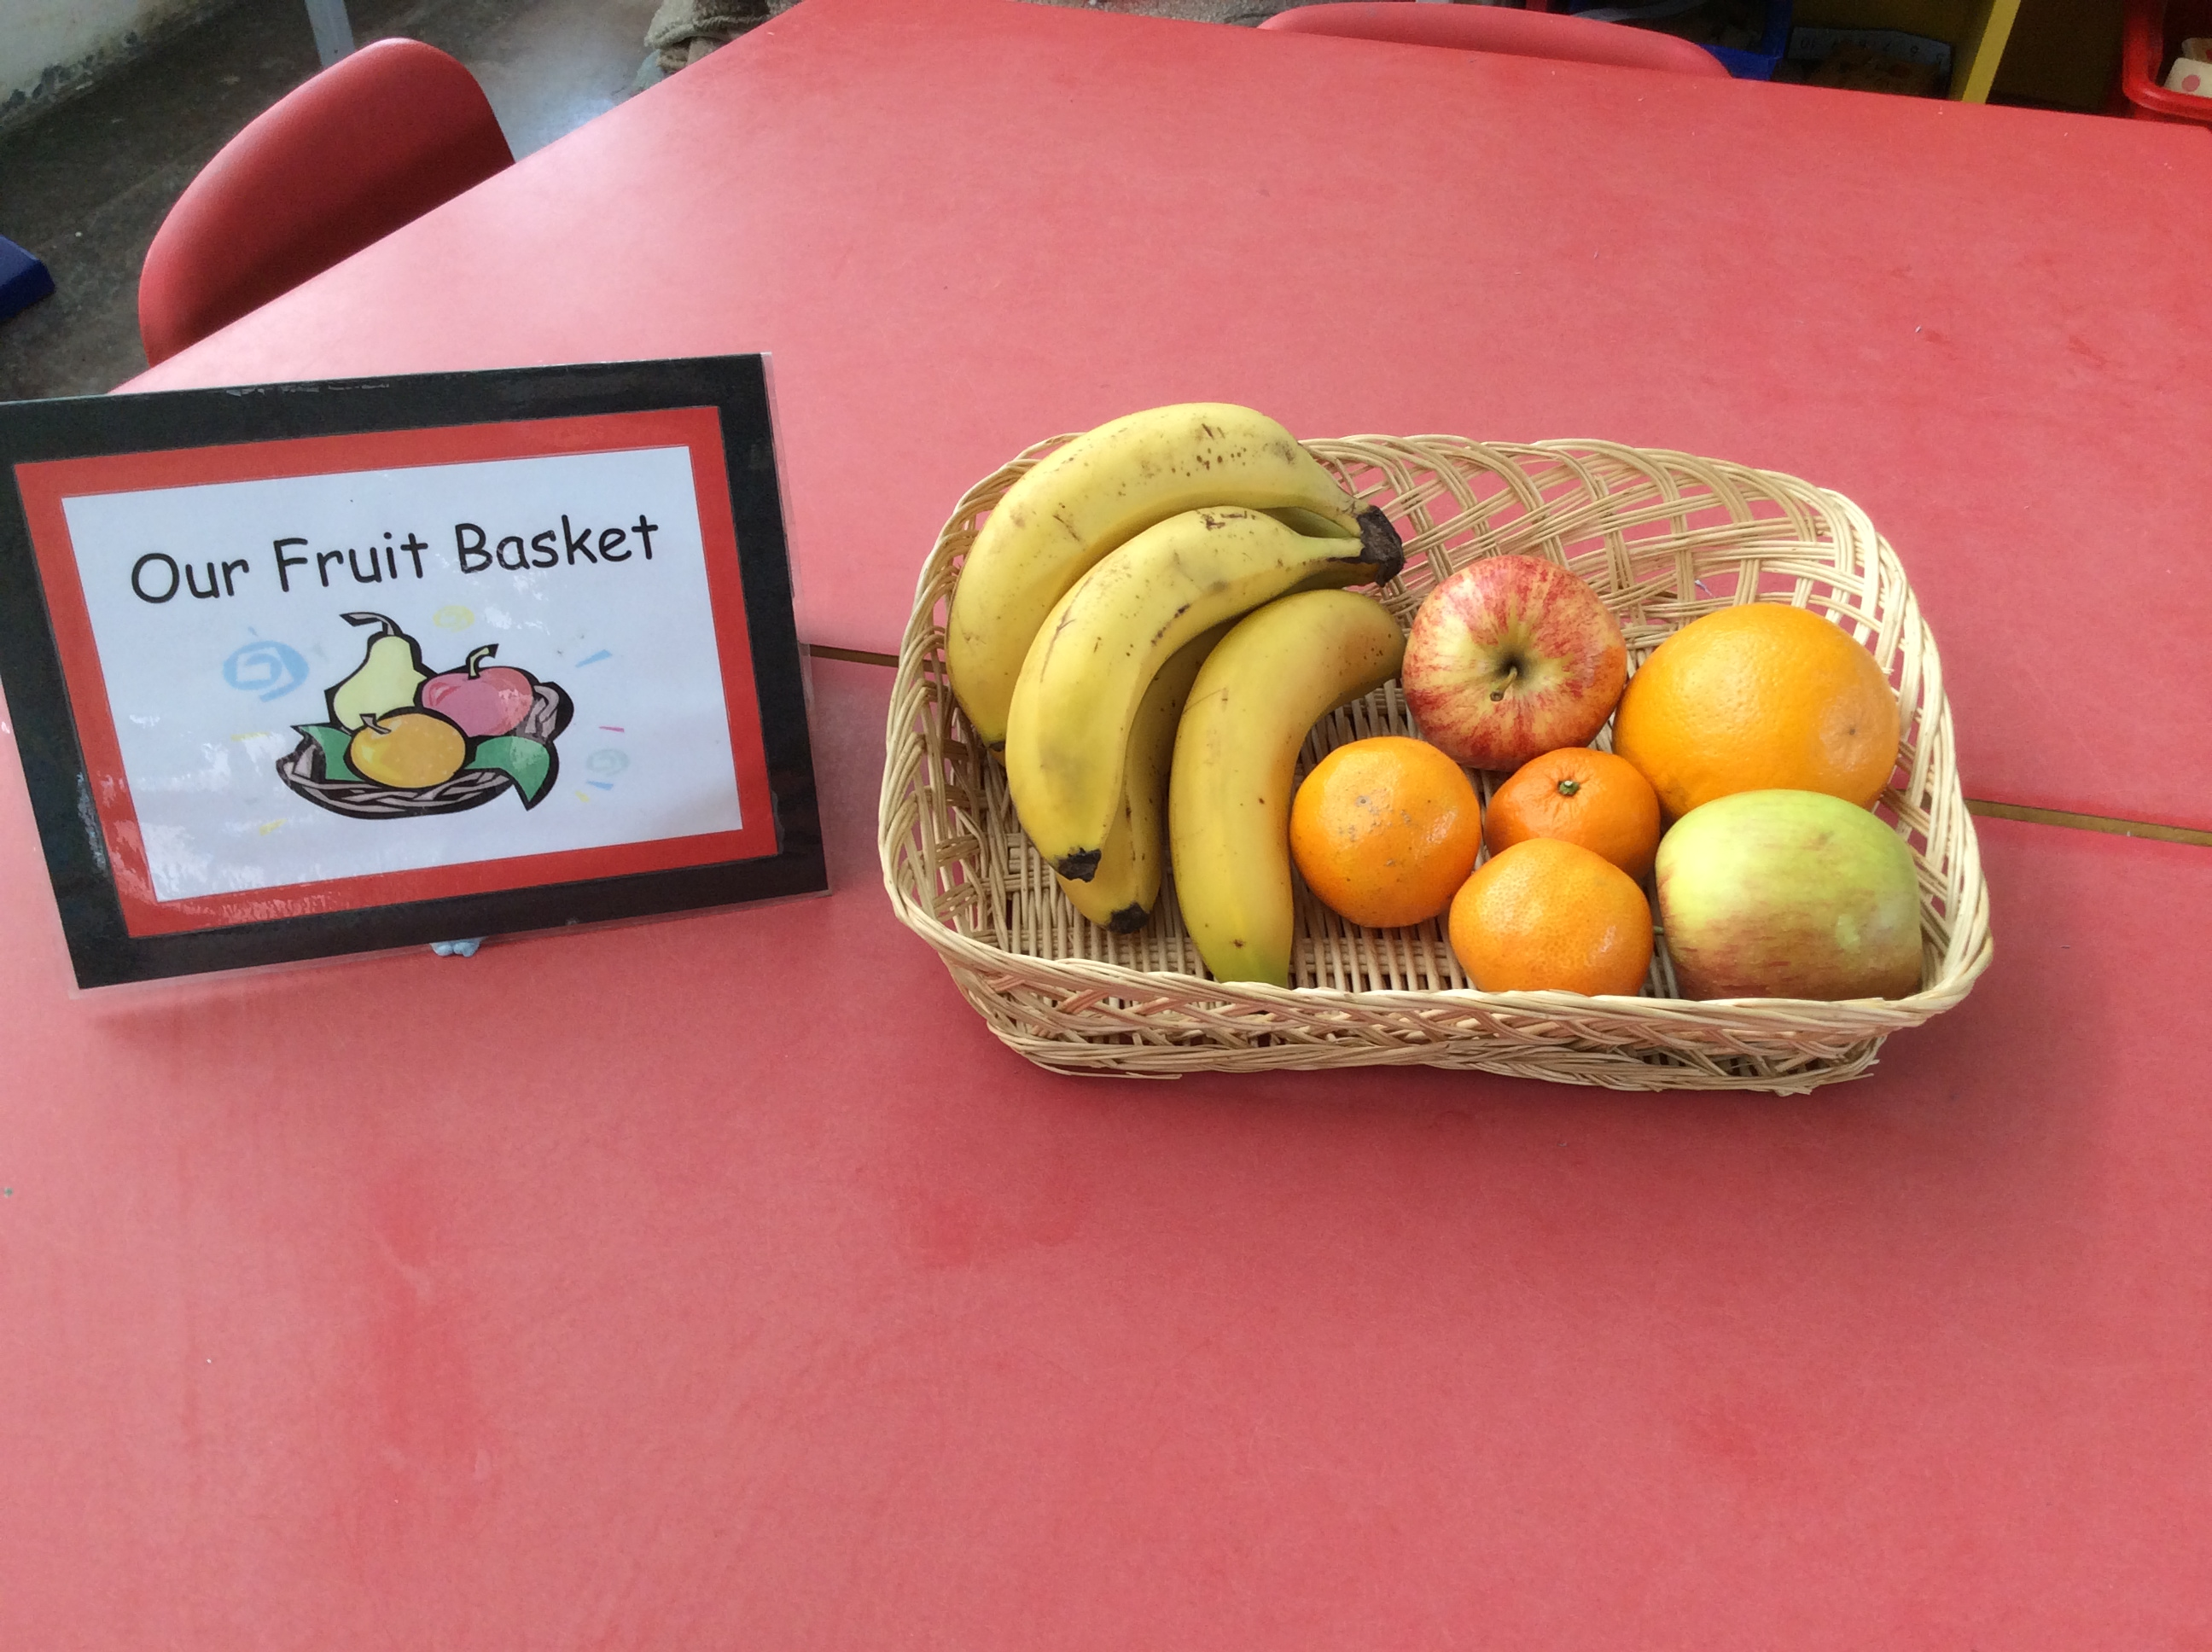
I will be given a Ladywell green reading folder.
A P.E kit to keep in school.
Fruit on a Monday for sharing as snack.

